Windows Remote Control

# Architecture document

## By Lucian Ion

### Date last updated: 16 Feb. 15

Use Case 1: Do you have more than one pc on the same room?

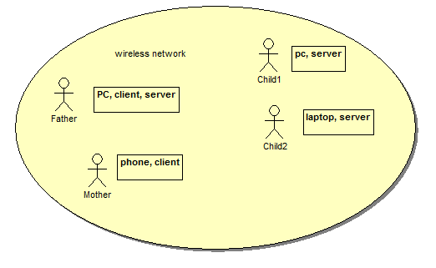

Are there times when you want to concentrate on reading the news and one of the kids PC are too noisy?

With this solution you can control volume on any pc in the room from one single point without having to disturb the other people and fight for the mouse.

Step 1: add the server to the stat-up on all the pc that might get too noisy.

Step 2: when any other computer is too noisy just connect with the client and adjust the volume.

In this project I use visual studio express 2013 for windows Desktop to build the windows server and test client.

The project is a C++ client server application running in Windows using async networking and win32 libraries.

The application was originally designed for remote controlling the sound volume.

Android client so one can control the volume from a phone application. The android client was developed using Java and Eclipse IDE.

Use Case 2: Do you use your laptop to play videos on TV via HDMI? Now the remote client can pause and play the pc media player!

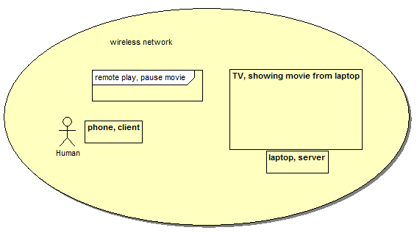

Remote mouse on the android client - move, click and double click events can be sent by android client via touchpad screen.

# Windows Server

Class Diagram

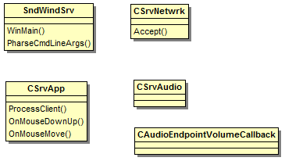

Windows Server Features:

* Be light enough so will not affect machine performance and can be left running at all times
* Be able to accept one connection from the network client
* Be able to change pc volume as instructed by the client
* Be able to generate mouse events as instructed by the client
* Start when user login

Because I want this to be light the windows server is single threaded, responds to UDP broadcast, accepts only one TCP/IP connection only. When Idle the server consumes less than 1 MB of the pc memory.

# Windows Client

Class Diagram

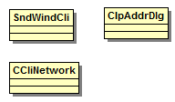

Windows Client Features:

* Lets user add a new connection by name or IP address
* Save the list of connections and loads the saved connections on start-up
* Connects and communicates with the server
* Read existing volume from the server
* Send commands to the server to adjust volume on the target machine
* Receives notifications if the target machine modifies volume and updates UI

# Android Client

Class Diagram

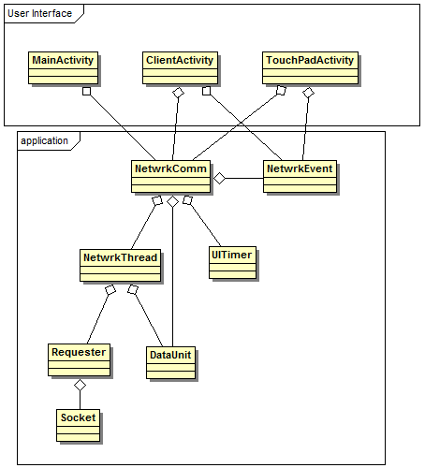

Android Client Features:

* Lets user add a new connection by name or IP address
* On new connection send broadcast message to local network
* Receives reply from the server and if not already in the list it uses it to populate IP address
* Save the list of connections and loads the saved connections on start-up
* Connects and communicates with the server
* Read existing volume from the server
* Send commands to the server to adjust volume on the target machine
* Receives notifications if the target machine modifies volume and updates UI
* Convert the touch events to mouse events and send them to the server in the touchpad screen